Board of Proprietors
St Catherine’s College Wellington Ltd

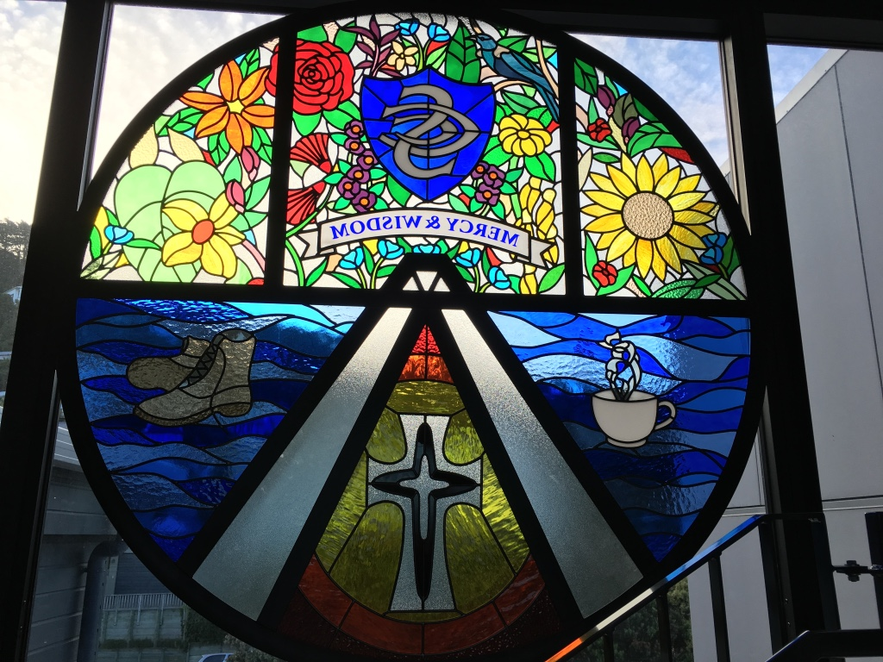

ST CATHERINE’S COLLEGE MERCY SCHOLARSHIP PROGRAMME 2019

St Catherine’s College is a Girls’ secondary school, owned by the Sisters of Mercy, and located in Upper Bourke Street, Kirbirnie. We are a Mercy school and that means we focus on:

Including everyone Standing together where help is needed
Caring for each other Celebrating cultural diversity
Having our door open

OUR AIM IS TO CREATE AN AURA OF SUCCESS AND AMBITION FOR OUR YOUNG WOMEN

We offer a full range of academic, cultural and sporting programmes and our young women consistently achieve results well above national levels. We’re really proud of them. Our aim is to have every young woman achieve the best that they can, whether that be in cultural, academic, sporting or other areas. At a senior level we share some classes with St Patrick’s College. This means our young women have the benefit of learning to work collaboratively with young men whilst enjoying the benefits of a single-sex college.

Applications are invited for the following Scholarships for 2019.

Te Atawhai Scholarship
Sister Mary Vincent Bourke Scholarship
Sister Mary Claude Copeland Scholarship
Sister Mary Phillippa McManus Scholarship
Sister Ethel Bignell Scholarship

Each Scholarship, to the value of $1,000, pays the Attendance Dues. These are paid directly in the name of the student.

The aim of these Scholarships, consistent with our Mercy values, is to enable young women, for whom the Attendance Dues would create difficulty for their families, to join us to experience our fantastic education in 2019. Preference is given to those “first in family” to attend St Catherine’s. The normal entry criteria apply and the Board of Proprietors reserves to right to determine whom the Scholarships are awarded to and how many are awarded in any year.

APPLICATION FORM

FULL NAME OF APPLICANT

Christian Names __________________________________________________

Surname __________________________________________________

Other siblings and ages ____________________________________________

Have any of your sisters or wider family attended St Catherine’s? _______________

CURRENT SCHOOL

Years Attended: / / to / /

Other Primary/Intermediate Schools Attended

Years Attended: / / to / /

Years Attended: / / to / /

Years Attended: / / to / /

NAME OF PARENT(S)/GUARDIANS

Christian Names _________________________________________________

Surname _________________________________________________

Christian Names _________________________________________________

Surname _________________________________________________

CONTACT DETAILS

Street _________________________________________________

Suburb _________________________________________________

City _________________________________________________

Telephone
Day _____________________ Evening ___________________
WHY WOULD YOU LIKE TO ATTEND ST CATHERINE’S?
(Think about what you enjoy doing at school, what you want to do when you attend College next year and why you think St Catherine’s would be a great place to be a part of. Tell us also about what you like do outside school. Feel free to continue onto another page if you have more to tell us.)

WHAT WOULD BEING AWARDED A MERCY SCHOLARSHIP MEAN TO YOU AND YOUR FAMILY?
(What difference do you think it might make to you and your family? How might it help your family? )

Can you please sign your name here:

___________________________________
CAN YOU PLEASE ASK YOUR PARENT(S)/GUARDIANS TO FILL IN THIS NEXT SECTION?

Parent(s)/Guardians, you and your daughter are asking that she be considered for a Mercy Scholarship for 2019. The Scholarships, awarded in the name of important Mercy women associated with the history of St Catherine’s, are to assist those families who wish to have a Mercy education for their daughter but for whom the Attendance Dues cause hardship. We therefore respectfully ask that you outline for us your family and general circumstances to us, together with how such a Scholarship will assist for 2019, so that we can consider this application.

In applying you understand that this Scholarship will see payment of Attendance Dues and a small proportion of the Proprietor Contribution only made in the name of your daughter for 2019. All other fees, contributions, uniform costs etc. outlined in the Prospectus will still apply.

SIGNED: __________________________________ DATE: / /

Name __________________________________

